

Student Name: M.W.V.D.M.J. Wijewickrama

Student Number: 2642837

Module Code: 6CS007

Module Name: Project and Professionalism

Project Title: An AI-Assisted Chest X-ray Training Companion for Student Radiologists Using MedGemma and Retrieval-Augmented Generation

Module Leader Name: Mr. Dhishan Dhammearatchi

Supervisor Name: Mr. Harindu Mansaka

Reader Name: Ms. Shanika Ekanayake

Submission Date: 2026/07/12

Award Title : BSc (Hons) Computer Science in Software Engineering (TopUp)

Declaration
Presented in partial fulfilment of the assessment requirements for the above award.
This work or any part thereof has not previously been presented in any form to the University or to any other institutional body whether for assessment or for other purposes. Save for any express acknowledgements, references and/or bibliographies cited in the work. I confirm that the intellectual contents of the work are the result of my own efforts and of no other person.
It is acknowledged that the author of any project work shall own the copyright. However, by submitting such copyright work for assessment, the author grants to the University a perpetual royalty-free licence to do all or any of those things referred to in section 16(i) of the Copyright Designs and Patents Act 1988. (viz: to copy work; to issue copies to the public; to perform or show or play the work in public; to broadcast the work or to make an adaptation of the work).


Student Name (Print): M.W.V.D.M.J. Wijewickrama
Student Number: 2642837
Signature of the Student: ......................................................
Date: ..............2026/07/12........................................

Abstract
Chest X-ray (CXR) interpretation is a core radiology skill that student radiologists develop through repeated case exposure and structured, individualised feedback. In settings affected by a shortage of radiologists, such supervised practice is difficult to provide at scale. This proposal presents a student-in-the-loop CXR training companion that combines MedGemma, a medical vision-language model, with Retrieval-Augmented Generation (RAG) to produce evidence-grounded, educational feedback for a narrow set of common findings. In the proposed workflow the student first records their own interpretation of a CXR image; MedGemma then analyses the image and proposes likely findings, and a RAG layer retrieves relevant teaching material and guidelines from a curated corpus. The system finally generates a student-facing feedback note that highlights likely findings, key radiographic signs, missed clues, supporting evidence and a learning point. The system is deliberately positioned as a formative learning aid rather than a clinical decision-support or diagnostic tool. The project follows a design-and-creation approach combined with an experimental, mixed-method evaluation that compares three configurations – MedGemma only, MedGemma + RAG, and, if feasible, a parameter-efficient fine-tuned MedGemma + RAG – using public datasets (NIH ChestX-ray and MIMIC-CXR). Technical performance is assessed through finding recognition and agreement with dataset labels, while educational feedback quality is assessed through a rubric measuring retrieval relevance, evidence grounding, clarity and usefulness for learning. The expected outcome is a working prototype and a practical framework for combining a medical vision-language model with RAG in an educational radiology setting, together with evidence on whether RAG improves the quality and trustworthiness of AI-generated feedback over the model alone.
Keywords: Chest X-ray; Radiology education; MedGemma; Retrieval-Augmented Generation; Vision-language models

Table of Contents

1 Introduction 1
1.1 Background 1
1.2 Problem Statement 1
1.3 Aims of the Project 2
1.4 Academic Questions 2
1.5 Objectives 2
1.6 Scope 3
1.6.1 In-Scope 3
1.6.2 Out-of-Scope 3
1.7 Structure of the Proposal 3
2 Literature Review 4
2.1 Introduction 4
2.2 Review of Existing Systems / Similar Work 4
2.3 Review of Related Concepts and Theories 5
2.4 Research Gap 5
2.5 Justification / Significance of the Study 6
2.6 Summary 6
3 Methodology 6
3.1 Introduction 6
3.2 Research / Development Approach 6
3.3 System Development Methodology 7
3.4 Requirement Gathering and Analysis 7
3.4.1 Functional and Non-Functional Requirements 7
3.4.2 Use Case Diagram 8
3.5 Proposed Artefact 9
3.6 Tools and Technologies 10
3.7 Resource Requirements 10
3.8 Project Plan and Timeline 11
3.9 Ethical Considerations 12
References 12
Appendix I – Existing Literature Overview Table 15
Appendix II – Evaluation Rubric (Draft) 15

List of Figures
Figure | Title | Page
Figure 3.1 | Use Case Diagram of the proposed training companion | 8
Figure 3.2 | High-level system architecture (MedGemma + RAG feedback pipeline) | 9
Figure 3.3 | Gantt chart of the project plan | 11

List of Tables
Table | Title | Page
Table 2.1 | Comparison of existing CXR interpretation systems | 4
Table 3.1 | Functional and non-functional requirements | 7
Table 3.2 | Proposed tools and technologies | 10
Table 3.3 | Project plan and timeline | 11
Table A.1 | Existing literature overview | 15

List of Abbreviations
Abbreviation | Full Meaning
AI | Artificial Intelligence
CXR | Chest X-ray
ERD | Entity-Relationship Diagram
GDPR | General Data Protection Regulation
LLM | Large Language Model
MIMIC-CXR | Medical Information Mart for Intensive Care – Chest X-ray
NIH | National Institutes of Health
NIST | National Institute of Standards and Technology
OWASP | Open Worldwide Application Security Project
PDPA | Personal Data Protection Act
PEFT | Parameter-Efficient Fine-Tuning
RAG | Retrieval-Augmented Generation
VLM | Vision-Language Model
WHO | World Health Organization

1. Introduction

1.1 Background
Medical imaging is central to modern hospital-based patient care, and the chest X-ray (CXR) remains one of the most frequently performed radiological examinations worldwide. Interpreting a CXR is a foundational competency for radiologists and many other clinicians, but it is a skill that develops slowly, through repeated exposure to varied cases and through structured feedback from experienced supervisors. Radiology training therefore depends heavily on the availability of expert time and on access to sufficient, well-labelled teaching cases.
In parallel, artificial intelligence (AI) has advanced rapidly in medical imaging. Medical vision-language models (VLMs) such as MedGemma can now jointly reason over an image and its associated text, and Retrieval-Augmented Generation (RAG) allows a language model to ground its output in external, verifiable knowledge sources. Most published systems, however, are framed around clinical diagnosis, automated report generation, or clinical decision support for qualified practitioners. Far less attention has been paid to using these same technologies to support students who are still learning to interpret images. This project investigates that under-explored space: an educational, student-facing CXR training companion that helps learners practise interpretation and receive evidence-grounded feedback, while remaining clearly separated from clinical use.

1.2 Problem Statement
Sri Lanka faces a significant shortage of radiologists, with only 0.78 radiologists per 100,000 population, compared with approximately 13 per 100,000 in Europe and 8.5 per 100,000 in the United Kingdom. This shortage can delay diagnosis and treatment because medical imaging plays a central role in patient care, and it is compounded by the high cost of training, by trainees remaining abroad after overseas training, by rising demand from an ageing population, and by ageing or inadequate imaging equipment that constrains hands-on training (Karunaratne, 2023). Because radiology training takes several years, the workforce shortage cannot be resolved quickly, and the training pipeline itself becomes a bottleneck.
Student radiologists therefore need repeated case exposure and structured feedback, yet individual supervised feedback on every practice case is rarely available at scale. At the same time, there is still no widely established, student-facing training companion that combines CXR image understanding with evidence-grounded explanations and feedback specifically designed for learning. Existing AI radiology systems concentrate on clinical support rather than on student practice, and there is limited evidence on how a medical VLM and RAG can be combined to produce reliable, useful educational feedback. This project addresses that gap.

1.3 Aims of the Project
The aim of this project is to design, implement and evaluate a student-in-the-loop chest X-ray training companion that uses MedGemma and Retrieval-Augmented Generation to provide structured, evidence-grounded educational feedback on a selected set of common CXR findings.

1.4 Academic Questions
The project seeks to answer the following main academic question and sub-questions, which follow directly from the problem statement and aim:
Main AQ: How can a medical vision-language model and Retrieval-Augmented Generation be combined to provide reliable, evidence-grounded feedback that supports student radiologists in practising chest X-ray interpretation?
AQ1: What limitations exist in current AI systems used for chest X-ray interpretation when they are considered as tools for student learning rather than clinical diagnosis?
AQ2: How can MedGemma be adapted or prompted to support student radiologists in practising interpretation of selected chest X-ray findings?
AQ3: Does Retrieval-Augmented Generation improve the grounding, clarity and educational usefulness of the feedback generated for chest X-ray training?
AQ4: Which configuration – MedGemma only, MedGemma + RAG, or fine-tuned MedGemma + RAG – provides the best balance between finding recognition, evidence grounding and feedback quality when evaluated against a defined rubric?

1.5 Objectives
The following SMART objectives will collectively achieve the aim:
- To review existing literature, models and systems related to AI-assisted chest X-ray interpretation and RAG, and to identify their limitations for educational use.
- To select a narrow set of common CXR findings and gather suitable public image data and labels for those findings.
- To gather and analyse the functional and non-functional requirements of a student-facing training companion, including the required feedback components.
- To design the architecture, data flow and a curated educational RAG corpus for the proposed system.
- To implement a working prototype that realises the student-attempt-then-AI-feedback workflow using MedGemma and RAG.
- To test and evaluate the prototype against defined success criteria, comparing MedGemma only, MedGemma + RAG and (if feasible) fine-tuned MedGemma + RAG, and to document the process and findings.

1.6 Scope

1.6.1 In-Scope
- Selected findings: A defined, narrow set of common chest X-ray findings suitable for student training. The candidate set is pneumothorax, pleural effusion, cardiomegaly, consolidation / airspace opacity, nodule or mass, and fracture; the final subset will be fixed by dataset label quality and availability.
- Core workflow: The student-in-the-loop workflow in which a learner first records their own interpretation, then receives MedGemma-based image analysis and RAG-retrieved evidence, and finally an educational feedback note.
- Platform: A prototype web application accessible via desktop browsers, using de-identified public CXR images only.
- Evaluation: A comparative evaluation of MedGemma only versus MedGemma + RAG (and fine-tuned MedGemma + RAG if time permits), covering both technical performance and educational feedback quality.

1.6.2 Out-of-Scope
- Clinical diagnosis, treatment or patient-management decisions – excluded because the system is an educational tool and clinical deployment is beyond the project's academic focus and approval.
- Use of real, identifiable patient data or live hospital images – excluded due to data-protection, ethical-approval and licensing constraints.
- Coverage of all thoracic diseases or all CXR abnormalities – excluded to keep the corpus, evaluation and timeline feasible for a final-year project.
- A native mobile application – excluded due to time constraints; the prototype targets desktop browsers only.
- Integration with hospital information systems or PACS – excluded as outside the educational scope and unavailable within the project constraints.

1.7 Structure of the Proposal
The remainder of this proposal is organised as follows. Chapter 2 presents a critical review of related academic work, existing systems and the core concepts underpinning the project, and identifies the research gap. Chapter 3 describes the proposed methodology, including the research and development approach, the software development methodology, requirement gathering, the proposed artefact and architecture, the tools and technologies, resource requirements, the project plan and timeline, and ethical considerations. The proposal ends with the reference list and appendices, including an overview table of the reviewed literature.

2. Literature Review

2.1 Introduction
This chapter critically reviews existing academic work, models and systems relevant to AI-assisted chest X-ray interpretation and to Retrieval-Augmented Generation in healthcare. The purpose is to position the proposed training companion against what already exists, to identify the strengths and limitations of current approaches, and to establish the gap that this project addresses. The review draws on recent peer-reviewed articles, technical reports and preprints on medical vision-language models, RAG for biomedicine, and chest X-ray interpretation systems.

2.2 Review of Existing Systems / Similar Work
A number of systems apply large multimodal models to chest X-ray interpretation. CXR-LLaVA and CheXagent are multimodal models built specifically for CXR understanding and report generation, and they demonstrate strong image-to-text capability; however, they are oriented towards clinical reporting rather than student learning, and they generally do not ground their explanations in retrievable teaching evidence (Lee et al., 2025; Chen et al., 2024). LLaVA-Med extends a general assistant to the biomedical domain efficiently, but it is broad rather than specialised for CXR education (Li et al., 2023). MedGemma is a medical VLM whose technical report shows competitive performance across image and text tasks, but its documentation stresses that intended uses require adaptation and validation for a defined use case, which motivates the educational framing adopted here (Sellergren et al., 2025).
Agentic and retrieval-oriented systems such as CXRAgent, MedRAX and multi-agent RAG frameworks for medical imaging show that combining retrieval and orchestration can improve reasoning and evidence use in radiology tasks (Lou et al., 2025; Pambudi and Menolascina, 2025). Benchmarks such as ReXVQA provide large-scale evaluation of CXR question answering (Pal et al., 2025). Across these systems, the dominant focus is diagnostic accuracy or clinical decision support; comparatively little work evaluates a student-facing workflow in which the learner attempts an interpretation before receiving grounded feedback. Table 2.1 summarises representative systems and their limitations for educational use, and a fuller overview is provided in Appendix I.
Table 2.1: Comparison of existing CXR interpretation systems
System / Study | Approach | Strengths | Limitations for education
CXR-LLaVA (Lee et al., 2025) | Multimodal LLM for CXR interpretation | Strong image-to-text; report generation | Clinical focus; no evidence grounding / RAG; not student-facing
CheXagent (Chen et al., 2024) | Foundation model for CXR | Broad CXR capability; benchmarked | Diagnostic orientation; limited educational feedback design
MedRAX (2024/25) | Agentic CXR analysis with tools | Tool use; structured reasoning | Clinical-decision focus; complexity; not learning-oriented
MedGemma (Sellergren et al., 2025) | Medical vision-language model | Multimodal medical reasoning; adaptable | Requires adaptation/validation; not an educational system by itself
RAG-in-biomedicine reviews (Liu et al., 2025) | RAG for biomedical LLMs | Improves grounding; systematic evidence | Retrieval quality varies; few CXR-education applications

2.3 Review of Related Concepts and Theories
Medical vision-language models combine an image encoder with a language model so that visual features can be described, questioned and explained in natural language. This is central to CXR interpretation, which requires both recognising radiographic signs and articulating the reasoning behind a finding (Sellergren et al., 2025; Chen et al., 2024).
Retrieval-Augmented Generation supplements a language model with an external knowledge base: a retriever selects relevant passages from a corpus, and the model conditions its output on those passages. In biomedicine, systematic reviews report that RAG can improve factual grounding and reduce unsupported claims, although retrieval quality and corpus curation remain decisive factors (Liu et al., 2025; Amugongo et al., 2025; Abo El-Enen et al., 2025). Related concepts include prompt engineering, which shapes model behaviour without changing weights, and parameter-efficient fine-tuning (PEFT), which adapts a model with limited compute; recent scoping work examines how fine-tuning and RAG can be integrated in healthcare AI (Collaco et al., 2026). Finally, educational theory on formative feedback and active learning underpins the student-first workflow: requiring a learner to commit to an interpretation before seeing AI output supports reflection and reduces answer-seeking behaviour.

2.4 Research Gap
Synthesising the review, four connected gaps emerge that link directly back to the problem statement in Section 1.2:
- Methodological gap: There are limited comparisons between prompting-only, RAG-based and fine-tuned + RAG approaches for educational chest X-ray training.
- Empirical gap: Few studies evaluate image-interpretation quality and evidence-grounded feedback quality together, especially in a student learning context.
- Knowledge gap: There is no clear best practice for combining a medical VLM with RAG to build a reliable, useful CXR training companion for students.

2.5 Justification / Significance of the Study
The study matters academically because it evaluates, in a controlled and narrow setting, whether RAG improves the usefulness, grounding and trustworthiness of AI-generated feedback – a question with limited existing evidence. It matters educationally because it reframes AI in radiology from replacing expert judgement towards supporting student learning and reflective practice. The direct beneficiaries are student radiologists, who gain access to structured, immediate, evidence-grounded practice feedback, and radiology educators, who gain a controlled baseline of formative support for common findings. More broadly, the framework contributes to the responsible-AI conversation by demonstrating a clearly bounded, educational-use design that avoids clinical deployment claims.

2.6 Summary
The literature shows strong progress in multimodal CXR interpretation and growing evidence that RAG improves grounding in biomedical applications, but a consistent focus on clinical rather than educational use, and little combined evaluation of interpretation and feedback quality for students. These insights directly inform the design and methodology in Chapter 3: a student-first workflow, a curated educational corpus, a comparative evaluation of MedGemma with and without RAG, and a rubric that measures grounding, clarity and usefulness alongside finding recognition.

3. Methodology

3.1 Introduction
This chapter describes the approach that will be taken to achieve the project's aim and objectives. It sets out the research and development approach, the software development methodology, the requirement-gathering plan, the proposed artefact and architecture, the tools and technologies, the resource requirements, the project plan and timeline, and the ethical considerations.

3.2 Research / Development Approach
The project follows a design-and-creation approach, because its central output is a novel software artefact – the training companion – whose construction is itself the vehicle for answering the academic questions. This is combined with an experimental strand, because the project systematically compares defined configurations (MedGemma only, MedGemma + RAG, and fine-tuned MedGemma + RAG) under controlled conditions. A mixed-method methodology is adopted: quantitative measures (finding recognition, agreement with dataset labels, retrieval-relevance scores) provide objective comparison, while qualitative, rubric-based assessment of feedback (clarity, grounding, usefulness) captures the educational dimension that numbers alone cannot. The mix is justified because the research question concerns not only whether findings are recognised but whether the resulting feedback is genuinely useful for learning.

3.3 System Development Methodology
An evolutionary prototyping methodology will be followed, applied within short iterations. Prototyping is appropriate because the requirements – particularly what constitutes good educational feedback – are not fully known in advance and are expected to be refined as the prototype is built and reviewed. Each iteration will deliver an increasingly complete slice of the workflow (image handling, MedGemma analysis, RAG retrieval, feedback generation, evaluation harness), allowing early testing and supervisor feedback. The iterations map onto the phases in the project plan (Section 3.8): an initial prototype establishes the MedGemma-only baseline, a second adds the RAG layer, and a final iteration adds optional fine-tuning and the full evaluation.

3.4 Requirement Gathering and Analysis
Requirements will be elicited mainly through document analysis of radiology teaching resources, dataset documentation and the reviewed literature, supplemented – where feasible – by informal consultation with a radiology educator or experienced reviewer to define what feedback student radiologists actually need. The target stakeholders are student radiologists (primary users), radiology educators (reviewers of feedback quality) and the developer/researcher. Functional and non-functional requirements will be documented and prioritised, and validated against the feedback components identified in the literature.

3.4.1 Functional and Non-Functional Requirements
Table 3.1: Functional and non-functional requirements
Type | Requirement
Functional | Display a chest X-ray image from a curated public dataset to the student.
Functional | Allow the student to record their own interpretation before any AI output is shown.
Functional | Analyse the image with MedGemma to propose likely findings and an initial explanation.
Functional | Retrieve relevant teaching evidence from a curated corpus using RAG.
Functional | Generate a feedback note: likely finding, key signs, comparison with the student's answer, missed clues, supporting evidence, and a learning point/mini-quiz.
Functional | Display retrieved source citations alongside the feedback.
Non-functional (Usability) | Feedback must be clear and understandable at the intended student level.
Non-functional (Reliability) | Separate model-suggested findings from retrieved teaching evidence; state uncertainty where appropriate.
Non-functional (Security) | Enforce role separation, secure secret handling, input/file validation.
Non-functional (Traceability) | Log prompt version, model version and retrieved passages for each feedback item to support evaluation.
Non-functional (Performance) | Return feedback within a reasonable interactive time on available hardware.

3.4.2 Use Case Diagram
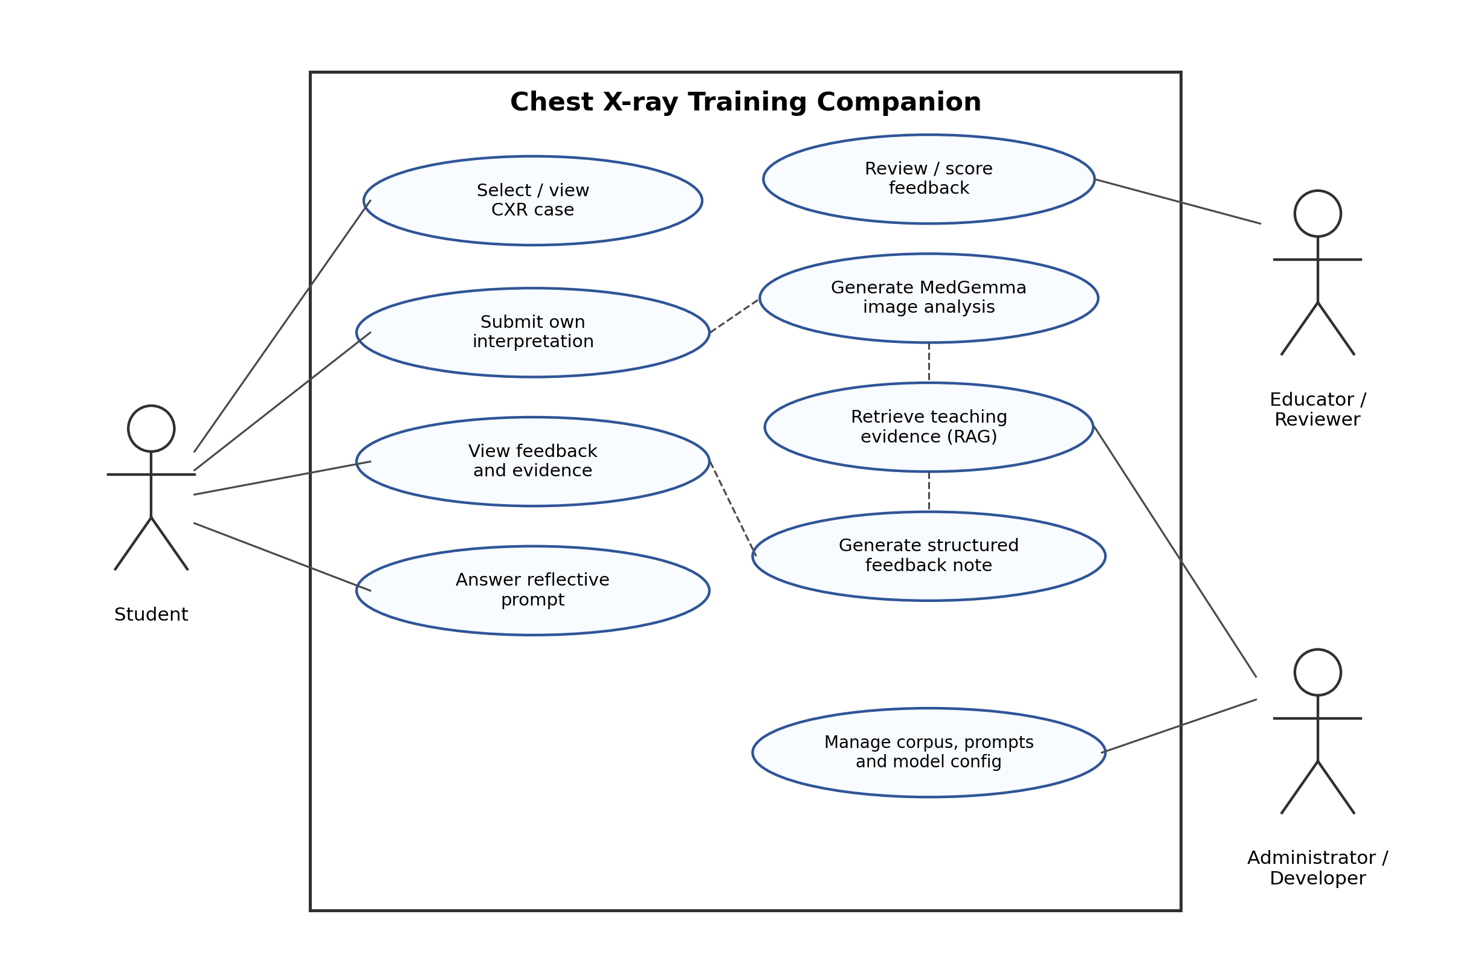
Figure 3.1: Use Case Diagram of the proposed training companion
The primary actor is the Student, who selects a case, submits an interpretation, views feedback and answers reflective prompts. A secondary actor, the Educator/Reviewer, reviews generated feedback and applies the evaluation rubric. The Administrator/Developer manages the corpus, prompt versions and model configuration. Key use cases include View CXR case, Submit interpretation, Generate AI analysis (MedGemma), Retrieve evidence (RAG), Generate feedback note, and Review/score feedback.

3.5 Proposed Artefact
The proposed artefact is a client-server web application organised in a layered architecture. A presentation layer (browser UI) handles case display and student input; an application layer orchestrates the workflow; a model-inference component runs MedGemma for image analysis; a retrieval component embeds the query and searches a vector database over the curated corpus; and a feedback-generation component composes the final student-facing note. Data modelling will capture cases, student attempts, retrieved passages and feedback records (documented with an ERD/class diagram during design). The end-to-end flow is: CXR case → student interpretation → MedGemma analysis → RAG retrieval → feedback generation → student reflection.
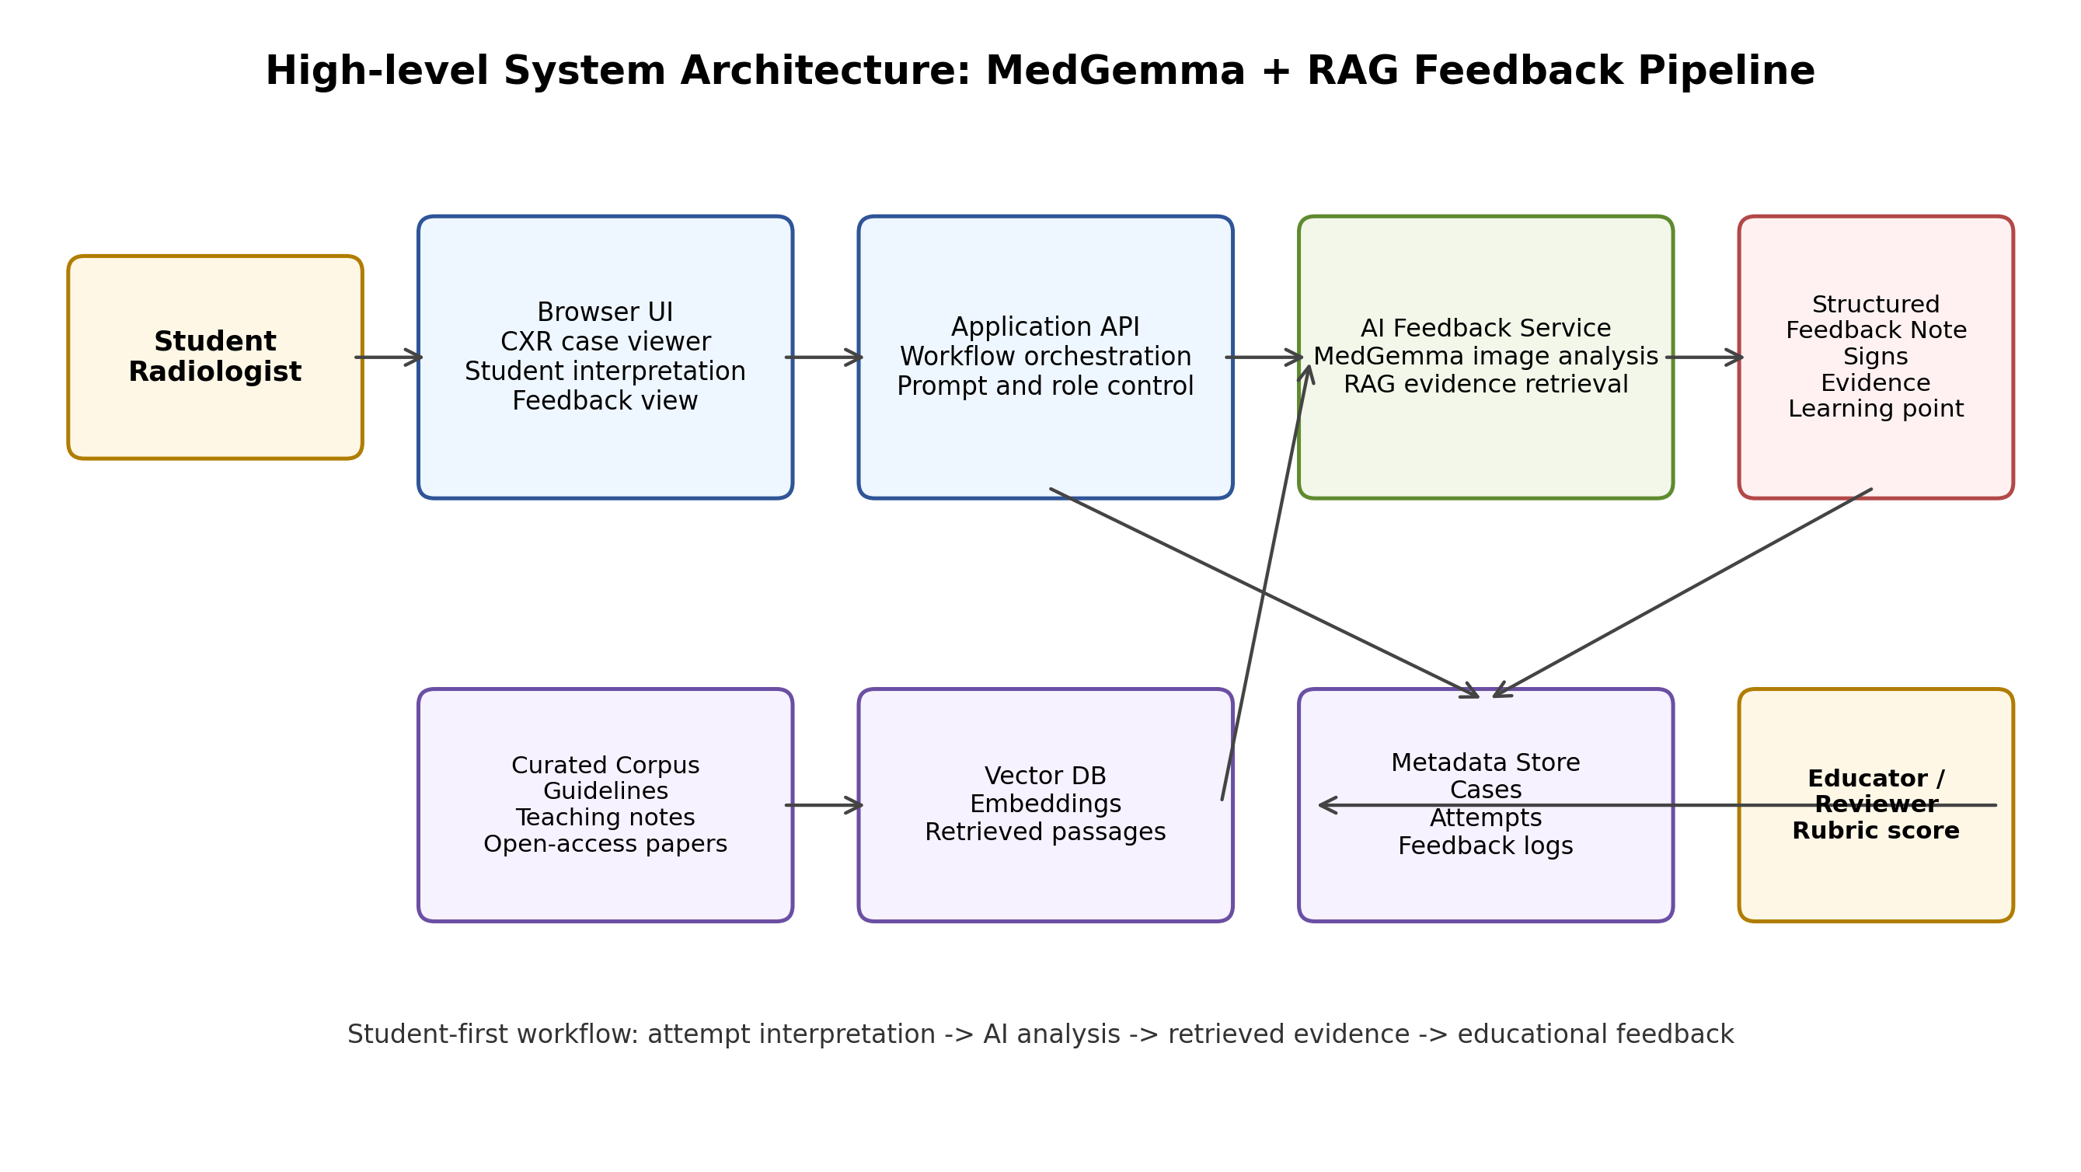
Figure 3.2: High-level system architecture (MedGemma + RAG feedback pipeline)
Each generated feedback note is planned to contain the following components:
- Likely finding
- Key radiographic signs
- Comparison with the student's answer
- Missed or incorrect reasoning
- Retrieved supporting evidence (with sources)
- Learning point or mini-quiz question

3.6 Tools and Technologies
Table 3.2: Proposed tools and technologies
Category | Tool / Technology | Justification
Programming Language | Python | Dominant ecosystem for ML/VLM and RAG tooling.
Medical VLM | MedGemma | Medical vision-language model suited to CXR image + text tasks.
RAG / Orchestration | LangChain or LlamaIndex | Mature frameworks for retrieval and generation pipelines.
Vector Database | FAISS or Chroma | Efficient similarity search over the curated corpus.
Embeddings | Biomedical / sentence-transformer embeddings | Domain-appropriate retrieval quality.
Backend Framework | FastAPI or Flask | Lightweight Python web/API layer for the workflow.
Frontend | React (or server-rendered templates) | Interactive student-facing UI in the browser.
Datastore | SQLite/PostgreSQL (metadata) | Store cases, attempts and feedback records.
Fine-tuning (optional) | PEFT / LoRA | Parameter-efficient adaptation within limited compute.
Development Tools | VS Code, Git/GitHub | Editing and version control.
Environment | Conda / venv, Jupyter | Reproducible experiments and analysis.

3.7 Resource Requirements
The project requires the following resources, obtained as noted:
- Compute: A GPU-enabled environment for MedGemma inference and optional fine-tuning, via a local GPU or a cloud/academic compute allocation.
- Datasets: Public, de-identified CXR datasets – NIH ChestX-ray and MIMIC-CXR (optionally MIMIC-CXR-JPG) – obtained under, and used strictly according to, their licences and access conditions.
- Models: Access to MedGemma model weights/API under its usage terms, and any embedding models used.
- RAG corpus: A curated educational corpus of open-access papers, openly licensed guidelines and approved teaching notes, with a source register recording every document.
- Software: Standard development machine, code editor and version control.

3.8 Project Plan and Timeline
Table 3.3 presents the work breakdown and timeline across the available weeks; the phases follow the iterative prototyping plan in Section 3.3. The Gantt chart is shown in Figure 3.3.
Table 3.3: Project plan and timeline
Phase / Activity | Duration | Deliverable
Literature Review & Proposal | Weeks 1–3 | Approved Proposal
Requirement Analysis & Data Selection | Weeks 4–5 | Requirements Document; selected findings & data
System Design & Corpus Build | Weeks 6–7 | Architecture/Design docs; curated RAG corpus
Implementation – MedGemma baseline | Weeks 8–9 | Baseline prototype (MedGemma only)
Implementation – RAG layer | Weeks 10–11 | MedGemma + RAG prototype
Implementation – optional fine-tuning | Weeks 12–13 | Fine-tuned + RAG (if feasible)
Testing & Evaluation | Week 14 | Test report; rubric-based feedback evaluation
Documentation & Submission | Week 15 | Final thesis / report
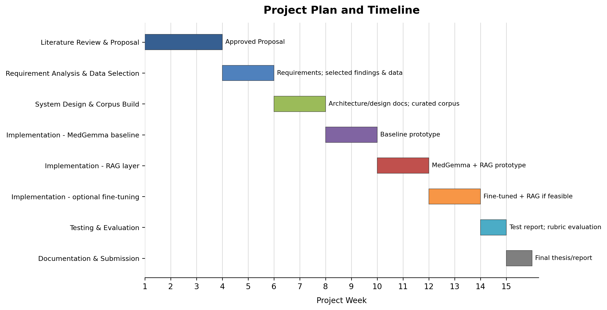
Figure 3.3: Gantt chart of the project plan

3.9 Ethical Considerations
Because the project involves medical images, automated feedback and student learning, ethical responsibility is important even though the system is not for patient care. The following issues will be addressed, consistent with the accompanying professionalism assessment and recognized guidance (World Health Organization, 2021; National Institute of Standards and Technology, 2023):
- Data protection and privacy: Only de-identified public datasets will be used, according to their licenses; no patient names, hospital numbers or other identifiers will be stored (Johnson et al., 2019; Wang et al., 2017).
- Student data: If student interpretations are collected for evaluation, participation will be voluntary, minimized, pseudonymous and separated from academic marking, consistent with the Personal Data Protection Act, No. 9 of 2022 (Parliament of Sri Lanka, 2022).
- Educational-use framing: The interface and report will state clearly that the system is for educational use only and not for diagnosis, treatment or patient management.
- Automation bias: A student-first workflow, visible sources, uncertainty statements and reflective prompts will be used to reduce over-trust in AI output (Liu et al., 2025).
- Licensing and IP: The RAG corpus will use only open-access or permitted sources, recorded in a source register; model and dataset licence terms will be respected.

References
Abo El-Enen, M., Saad, S. and Nazmy, T. (2025) 'A survey on retrieval-augmentation generation (RAG) models for healthcare applications', Neural Computing and Applications. Available at: https://doi.org/10.1007/s00521-025-11666-9 (Accessed: 9 June 2026).
Amugongo, L.M., Mascheroni, P., Brooks, S., Doering, S. and Seidel, J. (2025) 'Retrieval augmented generation for large language models in healthcare: A systematic review', PLOS Digital Health, 4(6), e0000877. Available at: https://doi.org/10.1371/journal.pdig.0000877 (Accessed: 27 May 2026).
Chen, Z. et al. (2024) 'A vision-language foundation model to enhance efficiency of chest X-ray interpretation', arXiv:2401.12208. Available at: https://doi.org/10.48550/arXiv.2401.12208 (Accessed: 18 June 2026).
Collaco, B.G. et al. (2026) 'Integrating fine-tuning and retrieval-augmented generation for healthcare AI systems: A scoping review', Bioengineering, 13(2), 225. Available at: https://doi.org/10.3390/bioengineering13020225 (Accessed: 2 June 2026).
European Parliament and Council of the European Union (2016) 'Regulation (EU) 2016/679: General Data Protection Regulation'. Available at: https://eur-lex.europa.eu/eli/reg/2016/679/oj (Accessed: 25 May 2026).
Gosai, A. et al. (2025) 'Beyond diagnosis: Evaluating multimodal LLMs for pathology localization in chest radiographs', arXiv:2509.18015. Available at: https://arxiv.org/abs/2509.18015 (Accessed: 13 June 2026).
Johnson, A.E.W. et al. (2019) 'MIMIC-CXR, a de-identified publicly available database of chest radiographs with free-text reports', Scientific Data, 6, 317. Available at: https://doi.org/10.1038/s41597-019-0322-0 (Accessed: 5 June 2026).
Karunaratne, D. (2023) 'The growing problem of radiologist shortage in Sri Lanka', Korean Journal of Radiology, 24(10), pp. 941-943. doi: 10.3348/kjr.2023.0791. Available at: https://pmc.ncbi.nlm.nih.gov/articles/PMC10550747/ (Accessed: 29 May 2026).
Lee, S., Youn, J., Kim, H., Kim, M. and Yoon, S.H. (2025) 'CXR-LLaVA: a multimodal large language model for interpreting chest X-ray images', European Radiology, 35(7), pp. 4374-4386. Available at: https://doi.org/10.1007/s00330-024-11339-6 (Accessed: 20 June 2026).
Li, C. et al. (2023) 'LLaVA-Med: Training a large language-and-vision assistant for biomedicine in one day', Advances in Neural Information Processing Systems 36. Available at: https://proceedings.neurips.cc/paper_files/paper/2023/hash/5abcdf8ecdcacba028c6662789194572-Abstract-Datasets_and_Benchmarks.html (Accessed: 31 May 2026).
Lin, Q. et al. (2025) 'Toward clinically explainable AI for medical diagnosis: A foundation model with human-compatible reasoning via reinforcement learning', arXiv:2509.03906. Available at: https://arxiv.org/abs/2509.03906 (Accessed: 16 June 2026).
Liu, S., McCoy, A.B. and Wright, A. (2025) 'Improving large language model applications in biomedicine with retrieval-augmented generation: A systematic review, meta-analysis, and clinical development guidelines', Journal of the American Medical Informatics Association, 32(4), pp. 605-615. Available at: https://doi.org/10.1093/jamia/ocaf008 (Accessed: 7 June 2026).
Lou, J., Yang, Y., Yu, Z., Fu, Z., Han, W., Huang, Q. and Yu, J. (2025) 'CXRAgent: Director-orchestrated multi-stage reasoning for chest X-ray interpretation', arXiv:2510.21324. Available at: https://arxiv.org/abs/2510.21324 (Accessed: 26 May 2026).
Mugambiwa, T. and Ndlovu, B. (2026) 'Multi-agent retrieval augmented generation for clinical decision support: A systematic review and integrative conceptual framework', Journal of Applied Informatics and Computing, 10(1), pp. 171-183. Available at: https://www.semanticscholar.org/paper/Multi-Agent-Retrieval-Augmented-Generation-for-A-Mugambiwa-Ndlovu/eeab620e9d8c8d0c4215b2d39bcced9fc4d9440c (Accessed: 11 June 2026).
National Institute of Standards and Technology (2023) Artificial Intelligence Risk Management Framework (AI RMF 1.0). Available at: https://doi.org/10.6028/NIST.AI.100-1 (Accessed: 3 June 2026).
OWASP Foundation (2021) OWASP Top 10: The ten most critical web application security risks. Available at: https://owasp.org/Top10/2021/ (Accessed: 19 June 2026).
OWASP Foundation (2025) OWASP Top 10 for Large Language Model Applications. Available at: https://owasp.org/www-project-top-10-for-large-language-model-applications/ (Accessed: 28 May 2026).
Pal, A. et al. (2025) 'ReXVQA: A large-scale visual question answering benchmark for generalist chest X-ray understanding', arXiv:2506.04353. Available at: https://arxiv.org/abs/2506.04353 (Accessed: 14 June 2026).
Pambudi, S. and Menolascina, F. (2025) 'Bridging clinical narratives and ACR Appropriateness Guidelines: A multi-agent RAG system for medical imaging decisions', arXiv:2510.04969. Available at: https://arxiv.org/abs/2510.04969 (Accessed: 1 June 2026).
Papageorgiou, P.S. et al. (2025) 'The role of large language models in improving diagnostic-related groups assignment and clinical decision support in healthcare systems: An example from radiology and nuclear medicine', Applied Sciences, 15(16), 9005. Available at: https://doi.org/10.3390/app15169005 (Accessed: 10 June 2026).
Parliament of Sri Lanka (2022) Personal Data Protection Act, No. 9 of 2022. Available at: https://parliament.lk/uploads/acts/gbills/english/6242.pdf (Accessed: 6 June 2026).
Sellergren, A. et al. (2025) 'MedGemma Technical Report', arXiv:2507.05201. Available at: https://arxiv.org/abs/2507.05201 (Accessed: 17 June 2026).
Wang, X. et al. (2017) 'ChestX-ray8: Hospital-scale chest X-ray database and benchmarks on weakly-supervised classification and localization of common thorax diseases', Proceedings of the IEEE Conference on Computer Vision and Pattern Recognition (CVPR), pp. 2097-2106. Available at: https://doi.org/10.1109/CVPR.2017.369 (Accessed: 30 May 2026).
World Health Organization (2021) Ethics and governance of artificial intelligence for health: WHO guidance. Geneva: World Health Organization. Available at: https://www.who.int/publications/i/item/9789240029200 (Accessed: 15 June 2026).
Zambrano Chaves, J.M. et al. (2025) 'A clinically accessible small multimodal radiology model and evaluation metric for chest X-ray findings', Nature Communications, 16, 3108. Available at: https://doi.org/10.1038/s41467-025-58344-x (Accessed: 4 June 2026).

Appendix I – Existing Literature Overview Table
Table A.1: Existing literature overview
System / Study | Approach Used | Strengths | Limitations
CXR-LLaVA (Lee et al., 2025) | Multimodal LLM for CXR interpretation | Strong CXR image-to-text; report generation | Clinical focus; no RAG grounding; not student-facing
CheXagent (Chen et al., 2024) | Foundation model for CXR | Broad CXR capability; benchmarked | Diagnostic orientation; limited educational feedback
CXRAgent (Lou et al., 2025) | Multi-stage orchestrated reasoning | Structured reasoning; agentic pipeline | Complexity; clinical rather than learning focus
MedRAX | Agentic CXR analysis with tools | Tool use; retrieval-augmented reasoning | Clinical-decision focus; not learning-oriented
MedGemma (Sellergren et al., 2025) | Medical vision-language model | Multimodal medical reasoning; adaptable | Needs adaptation/validation; not educational by itself
LLaVA-Med (Li et al., 2023) | Biomedical multimodal assistant | Efficient biomedical adaptation | General biomedical; not CXR-education specific
ReXVQA (Pal et al., 2025) | Large-scale CXR VQA benchmark | Standardised evaluation of CXR QA | Benchmark, not a training system; no feedback design
RAG reviews (Liu et al., 2025; Amugongo et al., 2025) | RAG for biomedical LLMs | Improves grounding; reduces unsupported claims | Retrieval quality varies; few CXR-education uses
Fine-tuning + RAG (Collaco et al., 2026) | Integrating PEFT and RAG | Combines adaptation and grounding | Scoping-level; not applied to CXR student training

Appendix II – Evaluation Rubric (Draft)
A draft rubric for assessing educational feedback quality, to be refined during design:
Criterion | Description
Finding recognition | Correct identification of the selected finding versus dataset labels.
Retrieval relevance | Relevance of retrieved evidence to the finding and feedback.
Evidence grounding | Extent to which explanations are supported by retrieved sources.
Clarity | Clarity of visual reasoning at the intended student level.
Usefulness for learning | Value of feedback for improving the student's reasoning.
Safety / trustworthiness | Avoidance of unsupported or overconfident claims.

